
Human Rights Division
United Nations Mission
in South Sudan

October-December 2025

Brief on Violence Affecting Civilians
HIGHLIGHTS

- Between October and December 2025, UNMISS Human Rights Division (HRD) documented 215 incidents of conflict-related violence affecting 830 civilians (121 women, 43 girls, and 56 boys): 406 killed, 264 injured, 106 abducted, and 54 subjected to conflict-related sexual violence (CRSV).

- Fifty percent of the victims (417 individuals) were attributed to the conventional parties to the conflict and other armed groups, while 47 percent (387 individuals) were attributed to community-based militias and/or civil-defense groups, and three percent (26 individuals) were attributed to unidentified/opportunistic armed elements.

- Compared with the previous quarter (July – September 2025), this represents a 27 percent decrease in the number of incidents (from 295 to 215) and a 28 percent decrease in the number of victims (from 1,153 to 830) documented. The number of civilians killed and injured decreased by 22 percent (from 519 to 406), and 33 percent (from 396 to 264) respectively, whereas the number of abductions and CRSV decreased by 33 percent (from 159 to 106) and 32 percent (from 79 to 54), respectively.

- Compared with the same quarter in 2024, this represents an eight percent decrease in the number of violent incidents (from 233 to 215), and a four percent decrease in the number of victims (from 866 to 830). The number of civilians killed increased by 15 percent (from 352 to 406), and those injured and abducted decreased by 25 percent (from 350 to 264) and 18 percent (from 129 to 106) respectively, while the number of those subjected to CRSV increased by 54 percent (from 35 to 54).
CONTEXT
Sub-national armed violence persisted across South Sudan, rooted in long-standing political instability, ethnic tensions, and weak governance structures that have enabled widespread human rights violations and abuses within an environment marked by limited accountability and fragile rule-of-law institutions. Throughout the reporting period, violence was driven by a combination of actors, including the conventional parties to the armed conflict and other armed groups, community-based militias and/or civil-defense groups, as well as opportunistic and/or unidentified armed elements.

The actions of these groups collectively sustained a volatile security landscape in which conflict-related violence remained pervasive, contributing to significant civilian harm. The continued proliferation of arms, the mobilization and manipulation of local armed groups, recurrent intercommunal disputes, and unresolved political and territorial grievances further entrenched cycles of violence. As a result, affected populations experienced loss of life, widespread displacement, and the destruction of civilian property, further eroding community resilience and worsening the already precarious human rights situation across conflict-affected areas.

This brief examines the impact of armed violence and provides an overview of the multifaceted trends and patterns observed between October and December 2025. It focuses on the four major forms of individual harm most commonly experienced by victims during the armed conflict—killing, injury, abduction, and sexual violence. Consistent with the previous quarter, the brief analyzes the conflict dynamics in South Sudan that continued to fuel violence affecting civilians, thereby further undermining the human rights situation within the broader political and security crisis.

The information contained in this brief was obtained from victim and eyewitness accounts as well as reports from secondary sources, including service providers, community leaders and local authorities identified during field missions organized by UNMISS Human Rights Division (UNMISS HRD). Unless otherwise specified, all information presented herein has been verified through independent and credible sources. All incidents of intercommunal violence are deconflicted with incidents documented by the UNMISS Civil Affairs Division. Incidents determined as cases of conflict-related sexual violence are corroborated in consultation with the UNMISS Women’s Protection Advisory Unit.

The data presented in this brief is non-exhaustive and likely underrepresents the scale of harm affecting civilians. Investigations by UNMISS HRD were constrained by limited resources, access denials, inaccessibility due to weather condition, severe flooding and poor road conditions, fear of reprisals among victims and witnesses, and underreporting of sexual violence due to social stigma, compounded by the recent political and security developments, which significantly restricted UNMISS to access the hotspots and conflict impacted areas.
In accordance with its mandate, UNMISS issued this brief to raise awareness and to serve as an advocacy tool aimed at reducing the impact of conflict related armed violence against civilians. The Mission continues to urge all stakeholders to take concrete action to end violence and to uphold the human rights of the people of South Sudan, including their rights to life, liberty, and security of the person.

The ongoing armed hostilities, compounded by the deteriorating political environment and persistent instability, continued to undermine the protection of civilians across South Sudan. During the fourth quarter of 2025 (October to December), the human rights and security landscape remained highly volatile, shaped by persistent violence driven by political power struggles and deep-rooted mistrust among parties to the conflict, entrenched ethnic divisions and longstanding community grievances, and increasing competition over natural resources. These dynamics further complicated efforts to advance sustainable peace and placed civilians at continued risk of harm.
GENERAL TRENDS

Protection challenges were further exacerbated by the spillover effects of the conflict in Sudan, the proliferation of small arms and light weapons facilitated by porous borders, displacement caused by internal conflict, alleged military mobilization by parties to the armed conflict—including cases of forced conscription and the militarization of children—the involvement of a range of armed groups, as well as the denial or obstruction of humanitarian access in parts of the country.

Between October and December 2025, UNMISS HRD documented 215 incidents involving 830 civilian victims, perpetrated by both conventional parties to the armed conflict and community-based militias and/or civil defense groups. The victims included 121 women and 99 children (56 boys and 43 girls), who were subjected to one of the four major forms of harm: 406 killed, 264 injured, 106 abducted, and 54 subjected to sexual violence. Compared with the previous quarter (July–September 2025), this represents a 27 percent decrease in conflict related incidents (from 295 to 215) and a 28 percent decrease in the total number of victims (from 1,153 to 830). When compared with the same quarter in 2024, this reflects an eight percent decrease in incidents (from 233 to 215) and a four percent decrease in victims (from 866 to 830).

Despite the overall decrease in documented incidents and victims, UNMISS HRD has reasonable grounds to believe that the data presented is not fully comprehensive. Underreporting is likely due to challenges in accessing victims, as well as significant movement and security constraints that limited monitoring in hotspots and conflict affected areas. The trends, patterns, and impact of violence outlined in this report must therefore be interpreted within this operational context.

Violence by the Conventional Parties to the Armed Conflict and other Armed Groups

In the fourth quarter of 2025, the human rights landscape in South Sudan further deteriorated as political instability and armed hostilities involving the conventional parties to the armed conflict intensified across several regions. Armed confrontations escalated, including clashes between internal factions within these parties, alongside the involvement of other armed groups and allied militias. The protection of civilians was significantly compromised by continued airstrikes, aerial bombardments, shelling, ground combat operations, and counter offensives, particularly in parts of Jonglei, Unity, and Upper Nile States. As in previous reporting periods, determining the exact number of civilian casualties attributable to these actors remained challenging due to pervasive insecurity and restricted access to conflict affected areas, which limited the ability of UNMISS HRD to reach affected populations and verify incidents.

During the reporting period, violence perpetrated by the conventional parties to the armed conflict and other armed groups remained the leading cause of civilian harm, accounting for 44 percent of all violent incidents and 50 percent of documented victims (417 individuals). This reflects a 71 percent increase in the number of victims compared with the previous quarter (rising from 244 to 417), and a 175 percent increase compared with the same quarter in 2024 (from 152 to 417), underscoring the escalating impact of hostilities on civilian populations.

Upper Nile State recorded the highest number of civilian harm attributable to the conventional parties to the armed conflict and other armed groups, accounting for 37 percent of all victims documented during the reporting period (153 out of 417). The human rights situation in the State remained volatile due to continued armed confrontations between the South Sudan People’s Defense Forces (SSPDF) and the Sudan People’s Liberation Army–In Opposition (SPLA IO), along with aligned White Army militia elements in Nasir, Longochuk, and Maiwut Counties. These hostilities posed serious risks to civilians and resulted in loss of life, destruction of civilian property, displacement, disruption of livelihoods, and restrictions on the delivery of humanitarian assistance. Civilians caught between frontlines were further exposed to forced recruitment, looting of property, and instances of sexual violence.

During the reporting period, UNMISS HRD documented at least four aerial attacks and bombardments in Ulang and Nasir Counties. Reports also indicated alleged forced mobilization by the SPLA IO and White Army in parts of Ulang County. In addition, incidents of arbitrary arrest and detention for the purpose of forced military conscription, allegedly carried out by the SSPDF, were documented.

Relatedly, in Jonglei State, the involvement of various actors in armed hostilities, with an increasingly evident ethnic dimension, further exacerbated the human rights situation and the protection of civilians in several parts of the State. Despite repeated calls for an immediate ceasefire and for full respect of the Revitalized Peace Agreement, civilians continued to bear the brunt of the conflict. Armed violence that initially spilled over into Nassir County, Upper Nile State, in May 2025 persisted sporadically and remained ongoing at the time of drafting this brief.

Further, while reports of mobilization by the White Army from Gawaar Nuer community intensified, including the recruitment of children in Ayod and Fangak Counties, spearheaded by their spiritual leader, Tut Makuach, armed clashes between the SSPDF and SPLA-IO, with the backing of their respective aligned armed groups, persevered in parts of Fangak County, further threatening the protection of civilians. Despite inaccessibility to many areas impacted by the conflict, UNMISS HRD verified at least seven aerial bombardments and airstrikes by the SSPDF and allied forces in parts of Lankien (Nyirol County), Motot (Uror County), and God Payams (Ayod County), resulting in 54 civilian casualties, of which 30 were killed and 24 others were injured.

Likewise, in Western Equatoria State, the protection and human rights situation remained volatile and unpredictable, driven by ethnic polarization and politically induced tensions linked to counter insurgency operations by Government security forces against the SPLA IO and the National Salvation Front (NAS). This was compounded by guerrilla style counter offensives allegedly carried out by a coalition of SPLA IO and NAS elements, as well as reported abductions in parts of Ibba, Maridi, Mundri East, and Tambura Counties for the purpose of forced recruitment.

In October 2025, in response to the insurgency, the vulnerability of the population was further exacerbated by reports of airstrikes conducted by the SSPDF on civilian-inhabited areas in Nagero County, resulting in additional displacement. During the reporting period, the State recorded a total of 54 victims of abduction allegedly perpetrated by SPLA IO and NAS element, the highest number documented in this quarter. Incidents of arbitrary arrest and detention of civilians by the SSPDF, based on their perceived affiliation with the SPLA IO, continued to undermine the safety and protection of civilians. In one documented case, the victims were shot and killed following their arrest.

In Unity State, the human rights landscape was marked by heightened risks and volatility, driven by escalating tensions between the SSPDF and the SPLM/A IO. Both parties bolstered and reinforced their positions across the State, supported by their respective aligned militia groups. Further contributing to instability were internal disputes and fragmentation within the SPLM/A IO, as well as the spillover effects of the ongoing conflict in Sudan, where both the Sudan Armed Forces (SAF) and the Rapid Support Forces (RSF) reportedly crossed into South Sudan through border areas in Unity State and the Ruweng Administrative Area.

The protection of civilians in the northern parts of the State and in the neighboring Ruweng Administrative Area was jeopardized by persistent fear of violence, fatalities, and displacement. These risks were compounded by armed clashes along the Sudan–South Sudan border, reportedly involving the SSPDF and RSF on one side and the SPLA IO and SAF on the other—as well as by confrontations between the SSPDF and SPLA IO in Mayom County in October. Additionally, harassment at SSPDF checkpoints and during military operations targeting civilians perceived to be SPLM/A IO supporters further restricted their freedom of movement and exacerbated their vulnerability.

Similarly, in Warrap State, civilians faced heightened threats of violence following armed clashes between the SSPDF and members of the Necessary Unified Forces (NUF), primarily from the SPLA IO, in Turalei Payam, Twic County, in October. The confrontation allegedly resulted in 41 civilian deaths and triggered forced displacement, destruction of property, and restrictions on movement and access to livelihood activities. These impacts further deepened the already dire conditions faced by the affected communities and underscored the fragile security context in which civilians continue to bear the brunt of political and military disputes.

Furthermore, in response to communal violence among Dinka sub-groups, the SSPDF allegedly conducted at least three airstrikes in Wunlit, Makuac, Ngabagok, and Paweng Payams in Tonj East County, leading to the displacement of civilians in the affected areas.

Further, in Eastern Equatoria State, the alleged alliance between the SPLA IO and NAS, and their subsequent armed clashes with the SSPDF, placed civilians at heightened risk of violence. In November 2025, civilians were reportedly displaced from their villages in Iyere Payam, Magwi County, following confrontations between the parties.

In Western Bahr el Ghazal, the human rights environment was adversely affected by airstrikes reportedly carried out by the SSPDF against SPLA/M IO positions in parts of Rocrocdong and Kuajiena Payams, Jur River County, in October, and by the ensuing tensions between the two groups. The military operations increased protection risks for civilians and resulted in population displacement and significant humanitarian needs.

Violence by Community-Based Militias and/or Civil Defense Groups

Armed violence perpetrated by community-based militias and civil defense groups persisted and continued to have a devastating impact on civilians, further aggravating an already complex human rights and humanitarian environment. This violence was driven by several factors, including the proliferation of small arms and light weapons facilitated by illicit trade, porous borders, and the alleged recirculation of previously seized weapons. It was also sustained by entrenched patterns of violence rooted in longstanding and unresolved grievances, as well as cyclical revenge attacks linked to cattle raiding, territorial disputes, and competition over natural resources and grazing land.

During the fourth quarter of 2025, these actors accounted for 60 percent of all incidents documented nationwide (129 out of 215) and 47 percent of civilian victims (387 individuals). Compared with the third quarter of 2025, this reflects a 30 percent decrease in the number of incidents (from 174 to 129) and a 53 percent decrease in the number of victims (from 831 to 387). The militarized nature of violence frequently displaced local populations and disrupted local economies. As a result, civilians were deprived of their rights to life and security, economic livelihood, and freedom of movement.

As in the previous quarter, Warrap State recorded the highest number of victims attributable to community-based militias and civil-defense groups, accounting for 17 percent of all victims nationwide and 69 percent of victims within the State. Persistent communal tensions in the area were driven by continued fragmentation among Dinka sub-groups, cross border violence involving armed Dinka and Nuer elements from neighboring Lakes, Western Bahr el Ghazal, and Unity States, as well as the absence of State and judicial authorities or representation in remote areas. During the reporting period, violence perpetrated by these groups resulted in 111 civilian casualties (48 killed and 56 injured), including eight women, six boys, and four girls.

Within Warrap State, widespread intra communal violence among armed elements from Dinka sub-groups remained the primary driver of civilian casualties, representing 13 percent of all documented victims. Cross border attacks and counterattacks involving armed elements from neighboring Lakes, Unity, and Western Bahr el Ghazal States accounted for an additional seven percent of civilian casualties within the State.

In Jonglei State, although violent incidents perpetrated by Murle armed elements from the Greater Pibor Administrative Area (GPAA) had declined in the previous quarter (July–September), during the current reporting period UNMISS HRD attributed 76 percent of incidents (19 out of 25) and 55 percent of victims (48 out of 88 individuals) within the State to these armed elements. Additionally, internal violence between the Gawaar and Lou Nuer resurfaced. For example, in October, a cattle-raiding incursion allegedly carried out by Lou Nuer elements against the Gawaar Nuer in Khorwai and Wau Payams, Ayod County, resulted in 18 civilians killed and 12 others injured. Furthermore, cross border attacks against Murle communities in the GPAA by Toposa armed elements from Greater Kapoeta, Eastern Equatoria, resulted in 88 victims across 25 documented incidents.

In Eastern Equatoria State, violence characterized by cyclical revenge, cattle raiding, and disputes over grazing rights involving various civil defense groups—including the Buya, Didinga, Dongotono, Logir, Lotuko, and Toposa—persisted. Cross border violence involving armed elements from the Murle community in the GPAA further contributed to insecurity. Between October and December, these actors were responsible for 23 incidents of violence affecting 59 civilians (49 killed, nine injured, and one abducted). The highest number of casualties (28 killed and two injured) was documented in Budi County.

In Unity State, communal clashes among Nuer sections and sub sections, as well as cross border incursions by Dinka Ciec armed elements from Yirol East County, Lakes State, against the Nyuong Nuer in Panyijar County, continued and posed persistent risks to civilian protection. Between October and December, UNMISS HRD documented 18 incidents of conflict related violence involving these actors, impacting 56 civilians.

In Lakes State, a persistent cycle of revenge fueled intracommunal violence among Dinka sub sections, alongside counterattacks by Nyuong Nuer armed elements from Panyijar County, Unity State. Despite efforts to facilitate local peace agreements and community engagement to address disputes, violence remained a significant threat to civilians. During the reporting quarter, 11 incidents of communal violence involving these groups were recorded, affecting 42 civilians—including three women (20 killed, 21 injured, and one subjected to sexual violence)

Violence by Unidentified and/or Opportunistic Armed Elements

Incidents of violence perpetrated by armed elements that do not fall within the aforementioned categories, but nonetheless bear characteristics linking them to ongoing conflicts or violence affecting civilians , based on factors such as the modus operandi of the suspected perpetrators, the locations of the incidents, and other relevant indicators (including the objective of the violence, clothing, and language used)—were also documented. Overall, violence involving these armed elements accounted for three percent of all civilian victims (26 individuals): 11 killed, five injured, and 10 subjected to sexual violence. The highest number of incidents and victims was documented in Western Equatoria State.

Sexual and gender-based violence (SGBV)

Sexual and gender-based violence (SGBV) remains pervasive and continues to pose a significant threat to the protection and well-being of civilians in South Sudan, particularly women and girls. Long standing gender inequalities and entrenched harmful social norms have contributed to an environment in which SGBV persists. It is also important to note that men and boys are among the survivors of such violations. The ongoing armed conflict further exacerbated risks, as displacement and the breakdown of community protection mechanisms increased the vulnerability of women and girls to SGBV.

During the fourth quarter of 2025, UNMISS HRD documented 57 incidents of SGBV affecting 58 survivors (53 girls and five women) across six States. Compared with the previous quarter, this represents a 14 percent decrease in documented incidents (from 66 to 57) and a 22 percent decrease in the number of survivors (from 74 to 58). Of the 58 survivors, 21 incidents were attributed to community members or neighbors, 19 to family members or relatives, and 18 to unidentified armed elements.

Western Equatoria State continued to record the highest number of SGBV incidents, with 34 cases involving 34 survivors (33 girls and one woman). Of these, 19 incidents were attributed to community members or neighbors, 12 to family members or relatives, and three to unidentified armed elements.

In addition to incidents of SGBV, UNMISS HRD documented 37 incidents of conflict related sexual violence (CRSV) affecting 54 survivors nationwide (36 women and 18 girls). As with SGBV, Western Equatoria State recorded the highest number of CRSV incidents, accounting for 49 percent (18 of 37) and affecting 33 percent of all survivors (18 of 54). This was followed by Western Bahr el Ghazal State, which accounted for 22 percent of incidents (eight cases) and 17 percent of survivors (nine individuals), and Central Equatoria State, which accounted for 19 percent of incidents (seven cases) and 19 percent of survivors (10 individuals). Collectively, these three States accounted for 69 percent of all CRSV survivors nationwide (37 of 54 individuals).

Conventional parties to the armed conflict and other armed groups were the primary perpetrators of CRSV, accounting for 48 percent of documented incidents (19 out of 37), involving 28 survivors (23 women and five girls). Opportunistic armed elements were responsible for 28 percent of incidents (10 out of 37), affecting 12 survivors (six women and six girls). Community based militias and /or civil defense groups accounted for the remaining 23 percent of incidents (nine out of 37), involving 16 survivors (eight women and eight girls).

UNMISS HRD has reasonable grounds to believe that incidents of SGBV and CRSV are significantly underreported due to a combination of factors, including social stigma, trauma, fear of retaliation, and limited access to formal justice mechanisms across South Sudan. Additionally, due to intersectional vulnerabilities, survivors—particularly women and girls—often face social pressure to seek compensation through customary courts or to marry the perpetrator, rather than pursuing accountability through the criminal justice system.

Overall, between October and December 2025, Warrap State experienced the highest number of incidents of violence affecting civilians, accounting for 25 percent of all victims nationwide (206 individuals), followed by Upper Nile State with 18 percent (153 individuals) and Jonglei State with 17 percent (142 individuals). While Warrap State was predominantly affected by communal violence involving community-based militias and/or civil defense groups, Upper Nile State was mainly impacted by violence perpetrated by conventional parties to the armed conflict and aligned armed groups, which collectively accounted for 37 percent of all victims nationwide.
GEOGRAPHICAL TRENDS

During the reporting period, persistent tensions and armed hostilities involving the conventional parties to the armed conflict, including internal divisions and confrontations among their own factions, significantly deteriorated the human rights and security situation in Jonglei, Upper Nile, Unity, and Western Equatoria States. Civilians in these areas were subjected to severe forms of violence, including indiscriminate airstrikes, shelling, and aerial bombardments allegedly carried out by the SSPDF and allied armed groups. These operations resulted in civilian casualties, large scale forced displacement, ongoing threats to life, and widespread fear and uncertainty. Jonglei and Unity States experienced the highest levels of military offensives, as armed confrontations continued despite repeated calls for cessation of hostilities by the United Nations and other international actors.

Warrap State recorded the highest number of killings (116 individuals) and injuries (82 individuals), accounting for 30 percent of all civilian casualties from killing and injury nationwide (198 out of 670 victims). This was followed by Upper Nile State with 20 percent (135 individuals) and Jonglei State with 19 percent (130 individuals). Western Equatoria State recorded the highest number of abductions, representing 51 percent of all victims nationwide (54 out of 106 individuals), followed by Upper Nile State with 17 percent (18 individuals). Western Equatoria State also documented the highest number of survivors of conflict related sexual violence (CRSV), accounting for 33 percent of all survivors nationwide (18 out of 54 individuals).

VICTIMS
Findings by UNMISS HRD indicate that men comprised the majority of victims documented during the fourth quarter of 2025, representing 73 percent (610 individuals). Women constituted the second largest group at 15 percent (121 individuals), while children accounted for 12 percent (99 individuals). However, beyond the direct impact of violence, women and children are disproportionately affected by the wider consequences of conflict, particularly with respect to access to health care, education, and livelihoods in areas marked by high levels of insecurity.

Furthermore, UNMISS HRD has reasonable grounds to believe that conflict related sexual violence affecting male survivors is significantly underreported due to social stigma.

Most adult male victims (73 percent) were either killed (321), injured (224), or abducted (65), largely in the context of armed confrontations and violence attributable to community-based militias and/or civil defense groups (315), conventional parties and/or other armed groups (282), and opportunistic armed elements (10). Women were primarily subjected to killing (45 percent), sexual violence (30 percent), injury (21 percent), and abduction (4 percent).

These violations were mainly perpetrated by conventional parties and/or other armed groups (84), community-based militias and/or civil defense groups (30), and opportunistic armed elements (seven).

The primary form of harm perpetrated against children was abduction (36 percent), followed by killing (30 percent), conflict related sexual violence (15 percent), and injury (15 percent). Abduction was the leading form of harm affecting boys, whereas sexual violence was the leading form of harm affecting girls.

UNMISS HRD identified three major categories of alleged perpetrators involved in conflict-related violence affecting civilians: i) conventional parties to the armed conflict and other armed groups: ii) community-based militias and/or civil defense groups; and iii) unidentified and/or other opportunistic armed elements.
PERPETRATORS
The conventional parties to the armed conflict and/or other armed groups were responsible for 50 percent (417 individuals) of the total number of victims, while community-based militias and/or civil defense groups accounted for 47 percent (387 individuals), and three percent (26 individuals) were attributed to opportunistic and/or unidentified armed elements. This category of perpetrators includes Government defense and security forces, as well as organized opposition armed groups, and was responsible for 32 percent of all incidents documented during the reporting quarter.

The second category of perpetrators consists of community-based militias and/or civil defense groups. Over the past year, these groups have been co opted, armed, and used as proxy armed elements by parties to the conflict and by local actors, contributing to the progressive militarization of intercommunal violence. This dynamic has been compounded by the involvement of wealthy elites—both at the local level and in Juba—who invest heavily in cattle ownership. In this context, so called “intercommunal” violence cannot be separated from broader local, regional, and national political and military dynamics.

The third category of perpetrators comprises unidentified armed elements, primarily associated with opportunistic violence. These actors often have historical links to either conventional parties or to community-based militias and/or civil defense groups but have increasingly acquired autonomy from their original sponsors. They now carry out acts of violence against civilians from their own or rival communities, frequently without clear strategic or military objectives.

2025 Annual Trends Compared to 2023 and 2024
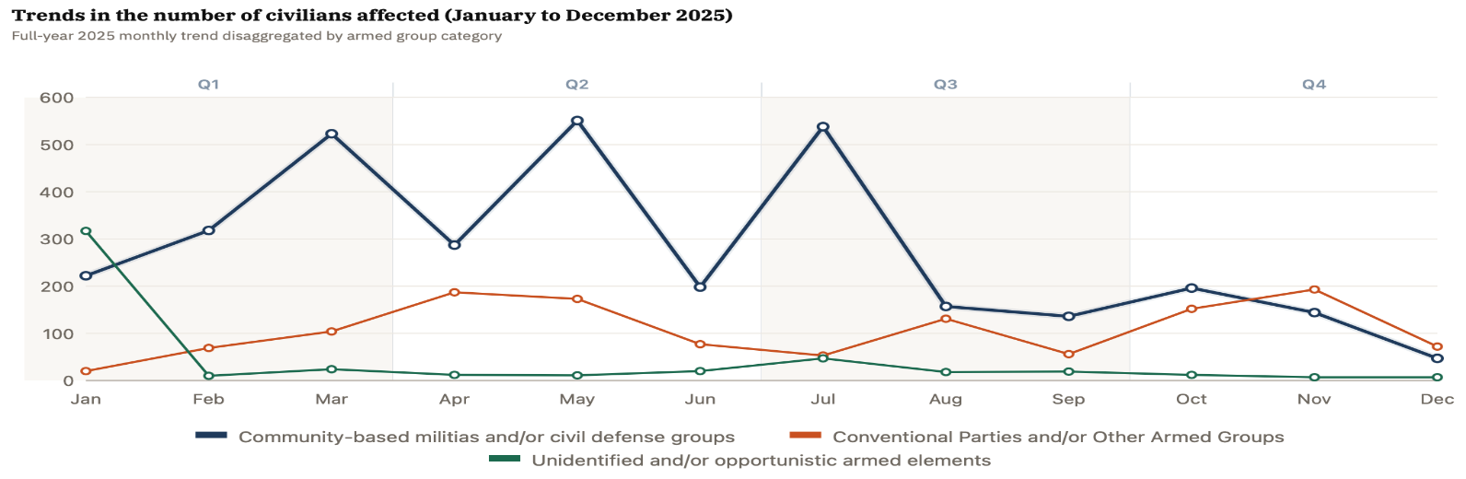
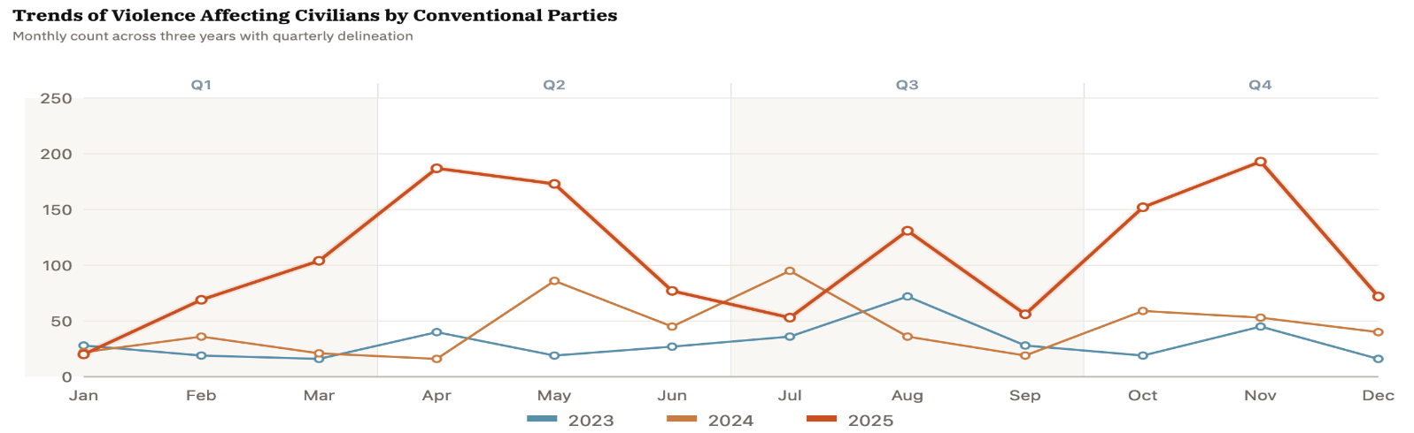

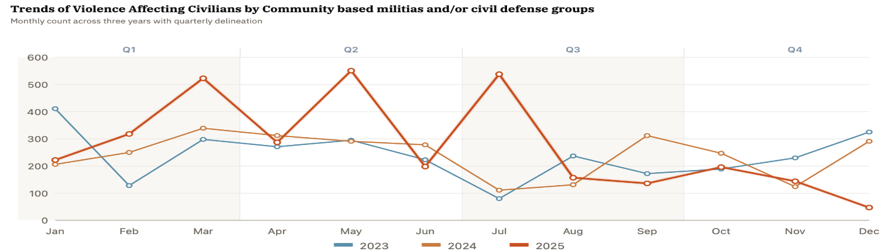

Advocacy Note

UNMISS urgently calls on all parties to the armed conflict to immediately cease all hostilities and to uphold their obligations under international humanitarian law and international human rights law. All actors must strictly and consistently respect the foundational principles of international humanitarian law, including distinction, proportionality, precaution, and military necessity, and must at all times refrain from directing attacks against civilians and civilian objects.

UNMISS further reminds the Government of South Sudan, as the primary duty-bearer, of its non-derogable obligation to prevent, protect, investigate, and ensure accountability for violations and abuses committed against civilians. This includes taking all necessary measures to ensure the safety and security of the population, investigate all alleged violations promptly, independently, and impartially, and to hold perpetrators accountable in accordance with international standards and fair trial guarantees.

UNMISS stresses that continued armed confrontations, deliberate targeting of civilians, indiscriminate attacks, and widespread violence, including killings, abductions, displacement, and sexual violence, represent grave violations of international law and constitute a direct affront to human dignity. These acts must end immediately.

UNMISS reiterates that impunity cannot be tolerated. Sustainable peace requires credible accountability, strengthened rule of law institutions, and concrete actions to dismantle armed networks responsible for ongoing violence. The Mission stands ready to support all genuine efforts toward peace, justice, and the protection of civilians, but emphasizes that the responsibility to end the violence and to prevent further suffering lies squarely with the parties themselves.

Location of Violence Affecting Civilians in South Sudan
October – December 2025

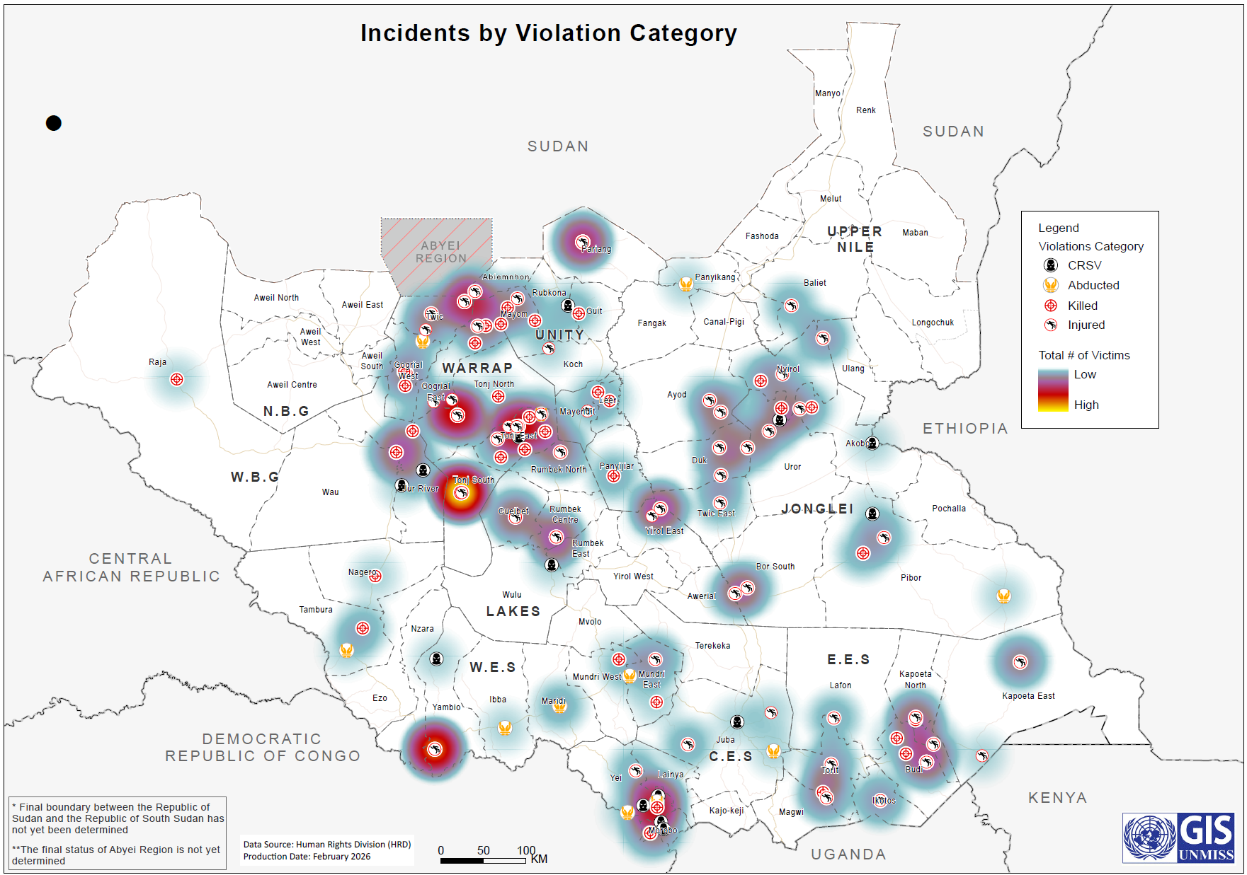

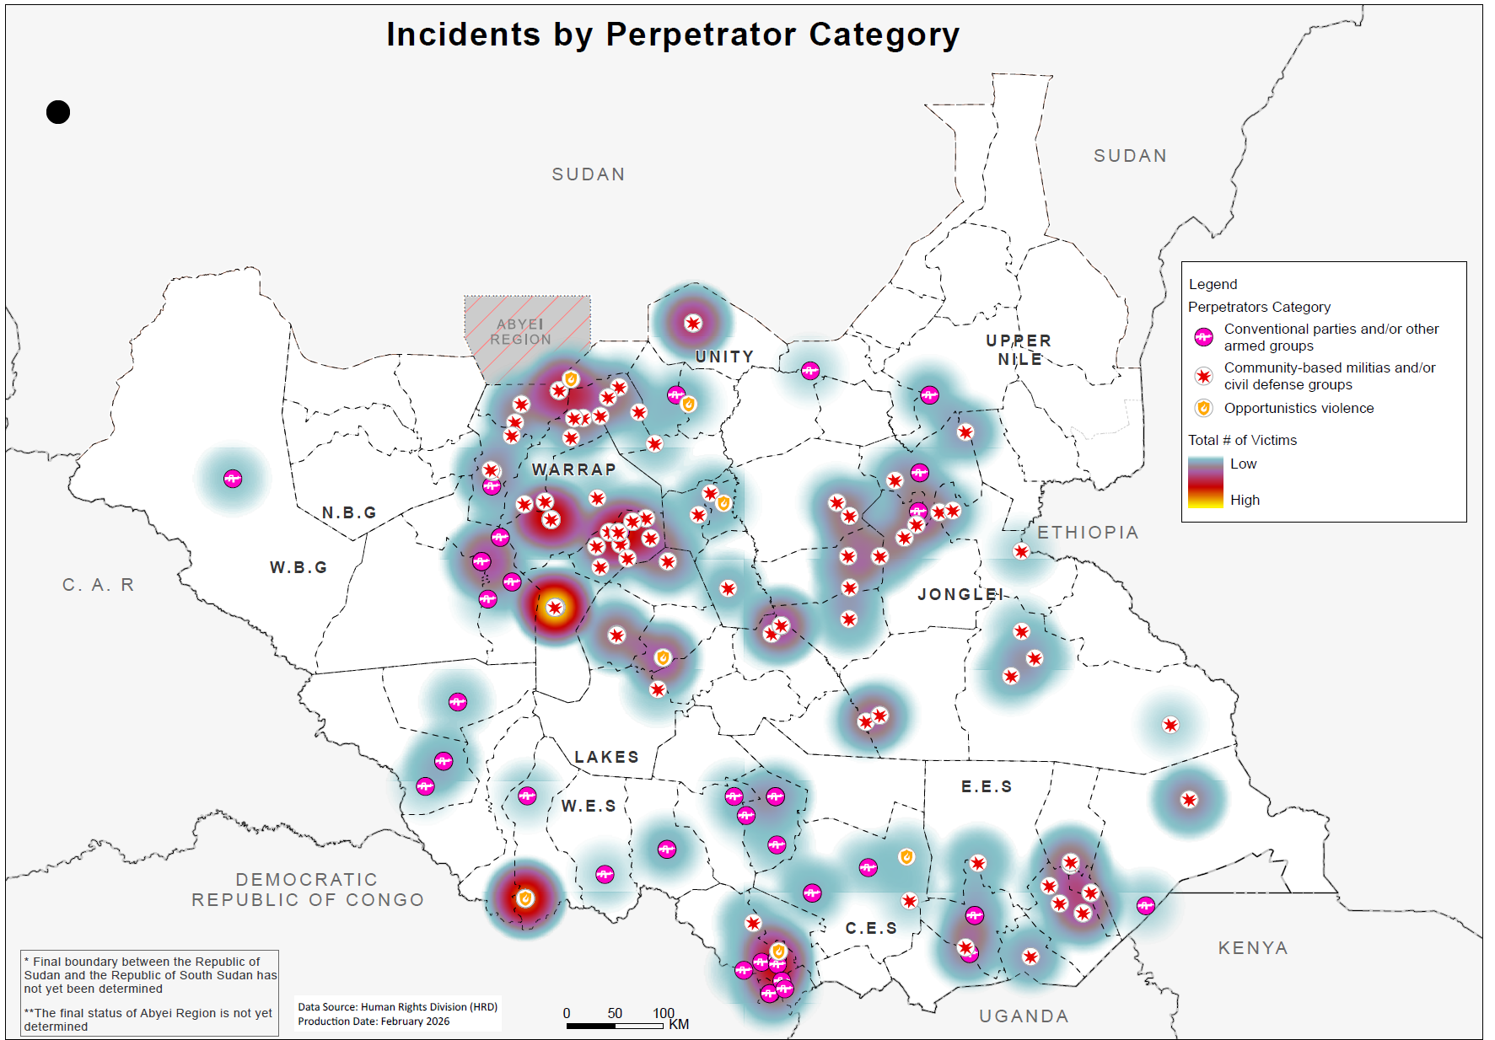

Between October and December 2025, UNMISS HRD interviewed and verified at least 43 victims of arbitrary arrest and detention for this purpose, of which two were children.

